Advanced JavaScript Frameworks (Angular)
TITLE PAGE
- Project Title: TASK MANAGEMENT & PRODUCTIVITY TRACKER
- Submitted By:
  - Team Members: Freida B. Rodrigues, Rishit Goyal, Deepak Reddy, Sarthak Sharma
  - Roll Numbers: 2460367, 2460435, 2460356, 2460487
  - College Email ID: freida.b@btech.christuniversity.in, rishit.goyal@btech.christuniversity.in, deepak.reddy@btech.christuniversity.in, sarthak.sharma@btech.christuniversity.in
- Course: Advanced Javascript Framework
- Institution: Christ (Deemed to be University)
- Date of Submission: 10/03/2026

Abstract
This project is a Task Management and Productivity Tracker built using Angular, TypeScript, and Angular Material to provide a modern, responsive web application for organizing work. Users can create, edit, categorize, and track tasks with fields such as title, description, category, priority, status, due date, and tags, all managed through validated reactive forms.

A modular architecture with dedicated components for task listing, details, and forms is connected via Angular routing with route parameters and guards for controlled navigation. Task data is handled by a centralized TaskService using RxJS Observables for real-time UI updates and persisted in JSON format through a mock backend plus local storage, ensuring that tasks are reliably stored and restored across sessions.

Objectives
- To design and develop a full-featured Task Management web application using Angular and TypeScript
- To implement Angular standalone components with modular architecture
- To apply reactive and template-driven forms with built-in Angular validation
- To manage task data using TypeScript interfaces, models, and a centralized TaskService
- To implement Angular routing with route guards for access control
- To create custom pipes and directives for dynamic UI behavior
- To integrate Angular Material components for professional UI design
- To use RxJS Observables and BehaviorSubject for async data management
- To persist task data using browser local storage
Scope of the Project
- Full frontend task management application with CRUD operations
- Task filtering by category, priority, status and search by title/tags
- Completion tracking with progress bar and statistics dashboard
- Angular Material UI with dark/light mode toggle
- Route-based navigation: All Tasks, Completed, Add Task, Task Detail, Edit Task
- Route guards restricting edit access to authenticated users (mock auth)
- Custom pipes: priorityColor, statusColor, categoryIcon, daysUntil
- Custom directive: OverdueDirective for visual highlighting of overdue tasks
- Data persistence via browser local storage using TaskService

Tools & Technologies Used
- Angular (v17 or latest): Frontend framework used to build the application
- TypeScript: Programming language used for application logic and type safety
- Angular Material: UI component library for professional, responsive design.
- HTML5: Used to structure the web pages
- RxJS: Reactive programming library for Observables and async operations.
- CSS: Used for styling and layout design
- Node.js: Runtime environment required for Angular development
- Angular CLI: Used to create, build, and run the Angular project
- Visual Studio Code: Code editor used for development
Project Structure
src/app/
- Main Angular application folder containing core files, components, services, and configuration.
src/app/components/
- All UI components.
- Includes: Navbar, Task Form, Task List, Task Detail, and Delete Confirm Dialog.
src/app/models/
- TypeScript models and interfaces defining the structure of task, user, and filter data.
src/app/services/
- Shared services, mainly TaskService for adding, updating, deleting, and loading tasks, with JSON/local storage persistence.
src/app/pipes/ and src/app/directives/
- Custom pipes and directives for formatting task data and highlighting overdue tasks.
src/app/guards/
- Route guards (e.g., mock auth guard) for protected navigation.
src/app/app.routes.ts
- Routing configuration for task list, add, edit, and detail views.
src/app/app.config.ts
- Global app configuration (router, HTTP client, animations, etc.).
src/app/app.ts
- Root component (shell) that contains the navbar and router outlet.
src/main.ts
- Application entry point, bootstrapping AppComponent with appConfig.

Key Features
- Create and manage tasks with title, description, category, priority, status, due date, and tags
- View, filter, search, and sort tasks in an interactive task list
- View full task details and update status or delete from a dedicated detail page
- Modern, user-friendly interface built with Angular Material and responsive design
- Reactive forms with validation for reliable task creation and editing
- Component-based architecture (navbar, task-list, task-form, task-detail, dialog) for modular design
- Central TaskService with RxJS Observables for real-time UI updates without page refresh
- Task persistence in JSON format, using a JSON file plus local storage to restore data across sessions

Challenges Faced & Solutions

Understanding Angular Standalone Components
- Challenge: Confusion about how to configure standalone components and attach Material modules.
- Solution: Imported CommonModule, RouterLink, FormsModule, and Angular Material modules directly in each component’s imports array.
Reactive Forms and Validation
- Challenge: Getting form controls, validators, and error messages to work correctly.
- Solution: Used FormBuilder and FormGroup with Angular validators, and displayed errors using mat-error and helper getters.
Date Handling and Datepicker
- Challenge: Ensuring users select dates only from a calendar and formatting them consistently.
- Solution: Integrated MatDatepickerModule and MatNativeDateModule, made the input readonly, and converted selected dates to YYYY-MM-DD in the form submit logic.
Task Data Persistence in JSON
- Challenge: Storing tasks so they survive refresh and are visible as a JSON file.
- Solution: Implemented a TaskService with BehaviorSubject and a small Node server that saves all tasks into tasks.json, while also mirroring them in localStorage.
Routing and Navigation Between Views
- Challenge: Navigating between list, add, edit, and detail pages with the correct task data.
- Solution: Configured Angular routes with parameters (e.g. /task/:id, /edit/:id) and used ActivatedRoute + TaskService to load the correct task in each component.

Outcome
- Built a complete Task Management and Productivity Tracker using Angular, TypeScript, and Angular Material.
- Implemented core features: create, edit, view, categorize, and track tasks with status, priority, and due dates.
- Achieved reliable data persistence by storing all task details in JSON format (JSON file + local storage) and restoring them on refresh.
- Applied key Angular concepts including standalone components, routing with parameters, reactive forms with validation, services with RxJS Observables, custom pipes, and directives.
- Delivered a modern, responsive, and user-friendly UI, demonstrating good frontend architecture and real-world application design skills.

Future Enhancements
- User authentication and profiles: Allow multiple users to log in and manage their own separate task lists.
- Reminders and notifications: Add email or in-app reminders for upcoming and overdue tasks.
- Advanced analytics dashboard: Show charts for productivity trends, completion rates over time, and category-wise breakdown.
- Drag-and-drop Kanban board: Visual board view (To-Do, In Progress, Done) with drag-and-drop task management.
- Cloud or database backend: Replace the mock JSON/local storage with a real REST API and database for multi-device access

Component Description
Navbar Component
The Navbar component provides persistent navigation across the application. It displays links to All Tasks, Completed Tasks, and Add Task views. It subscribes to the TaskService to show real-time counts of active and overdue tasks. It also includes a Light/Dark mode toggle.
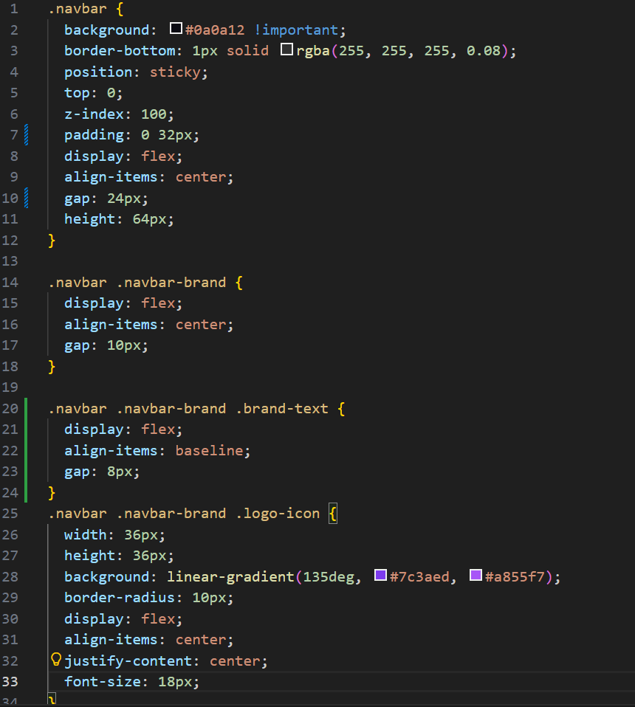

Tasks

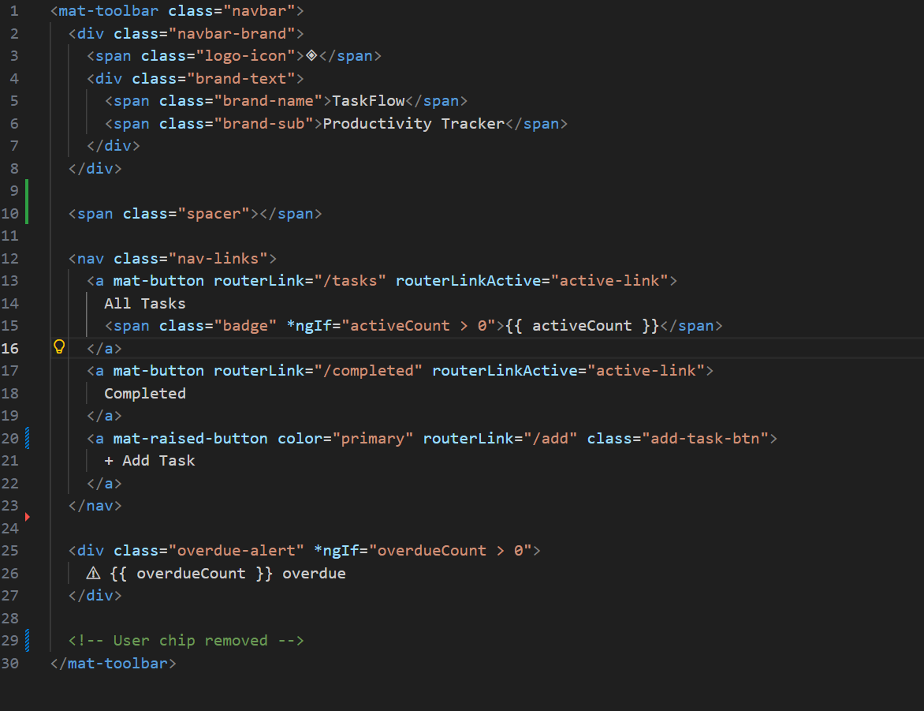

Typescript:
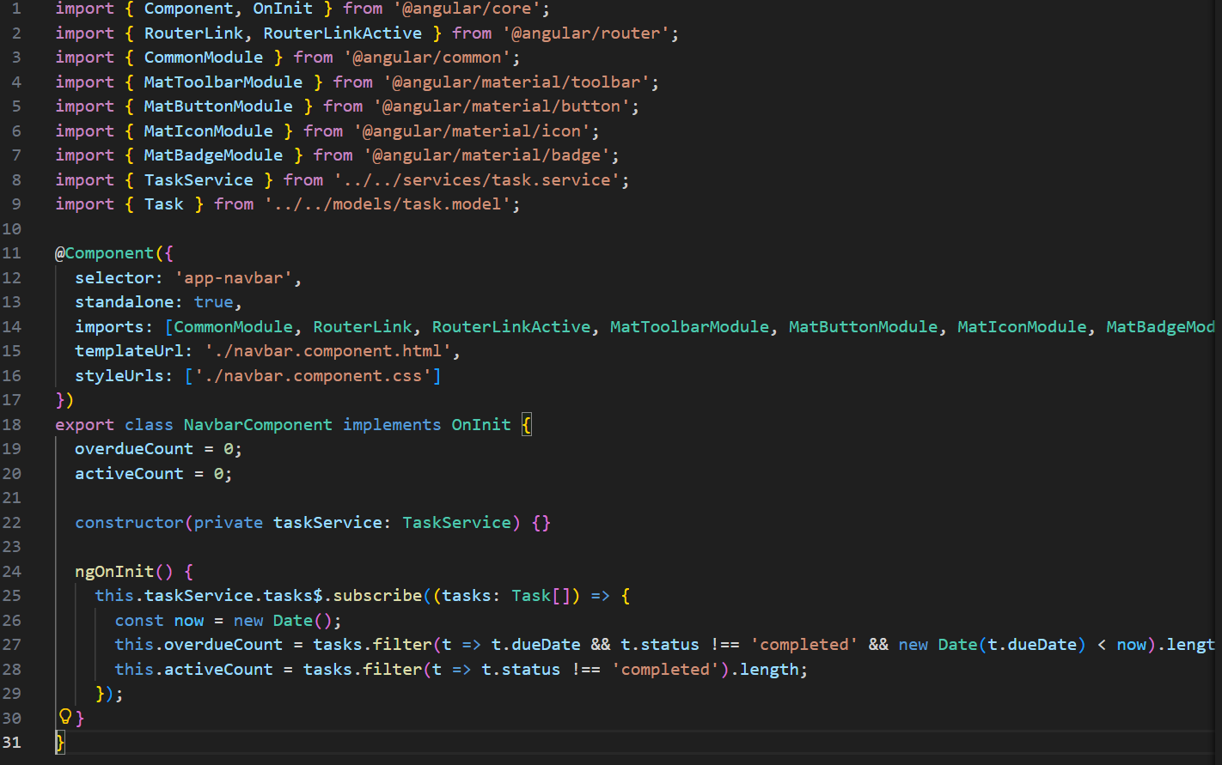

New Task

Task List Component
The Task List component is the main dashboard view. It displays tasks in a responsive grid or list layout with filtering, searching, sorting, a completion rate progress bar, and statistics panel.
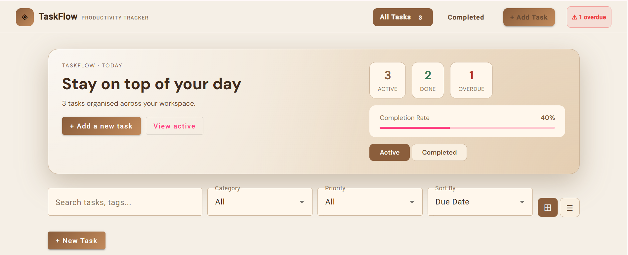

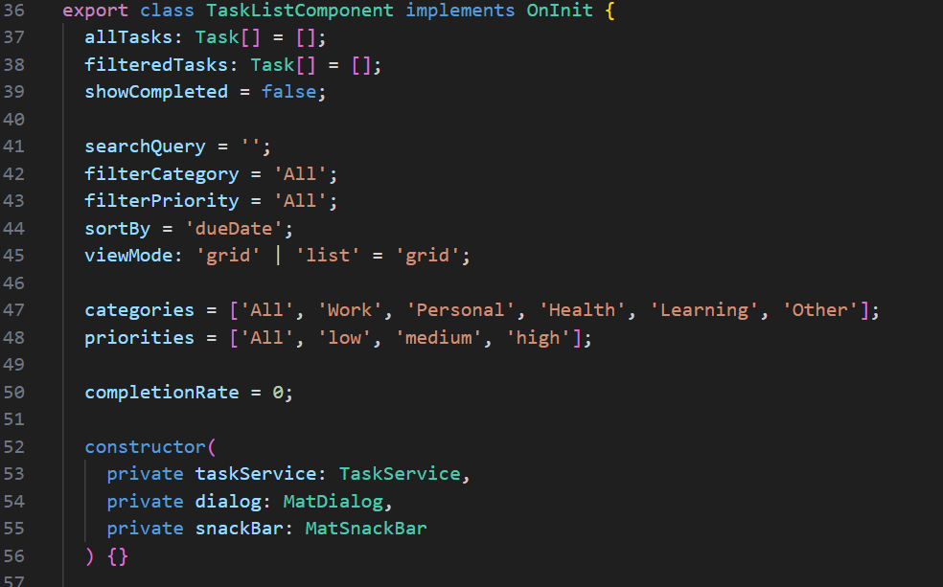

Task Form Component
The Task Form component handles both creating new tasks and editing existing ones using Angular Reactive Forms with FormBuilder and Validators. It detects edit mode via route parameter and pre-populates using patchValue.
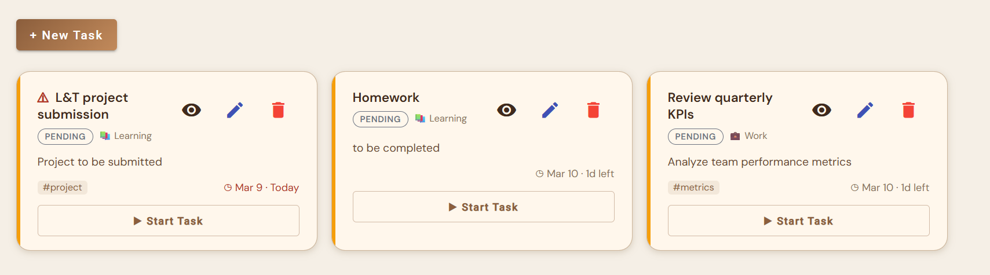
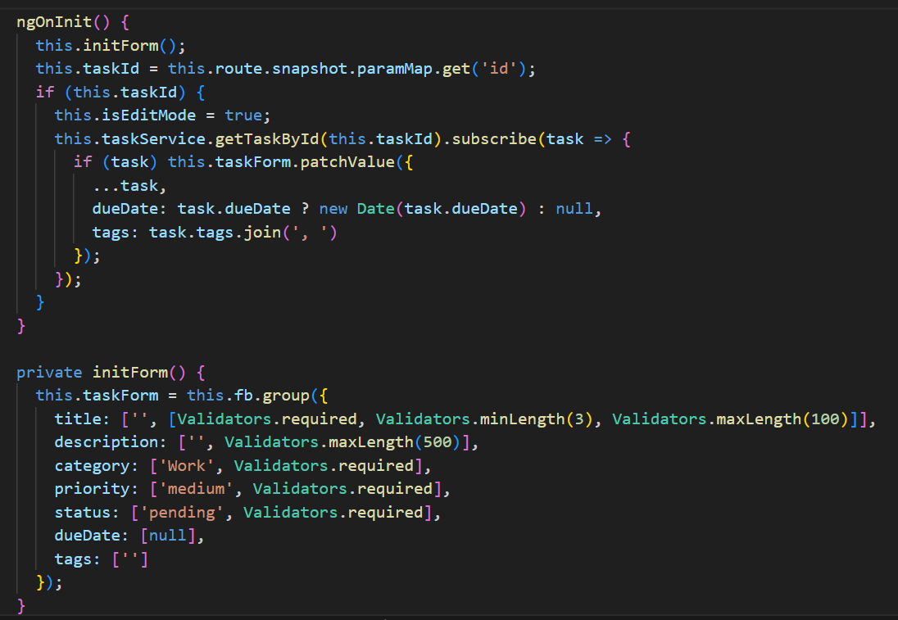

Task Detail Component
The Task Detail component displays full task information by ID. It shows priority, status, category, due date, tags, and timestamps with quick action buttons to start, complete, edit, or delete.
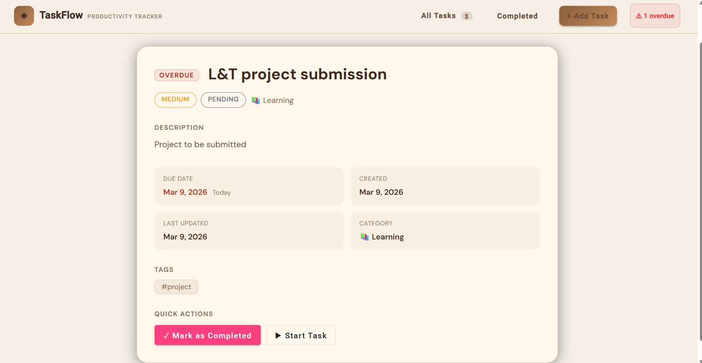

Delete Confirm Dialog
A reusable MatDialog component that prompts the user to confirm task deletion. Returns a boolean result via MatDialogRef.close() to prevent accidental deletions.

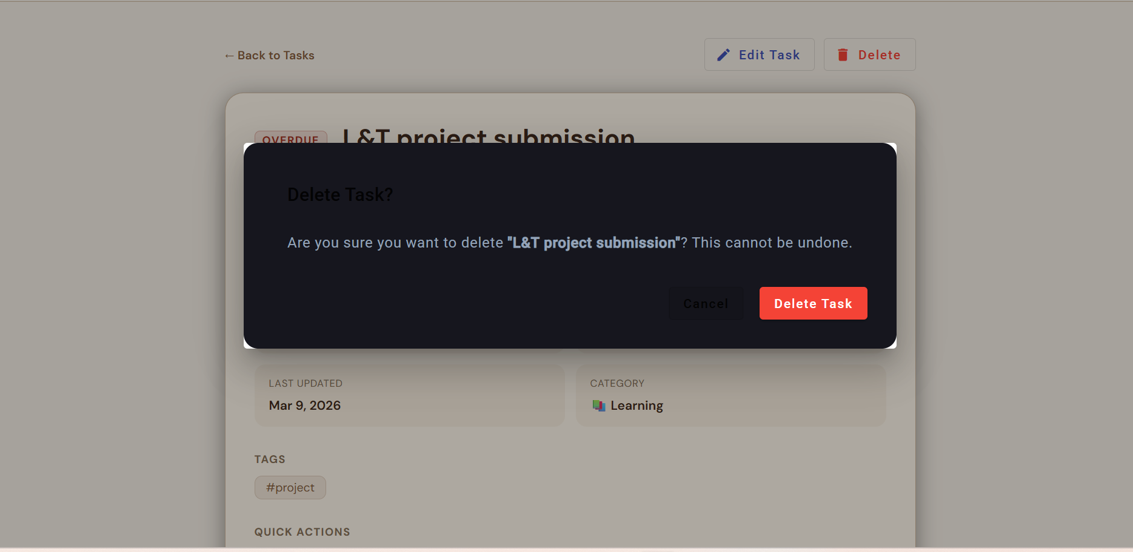

Task Model (task.model.ts)
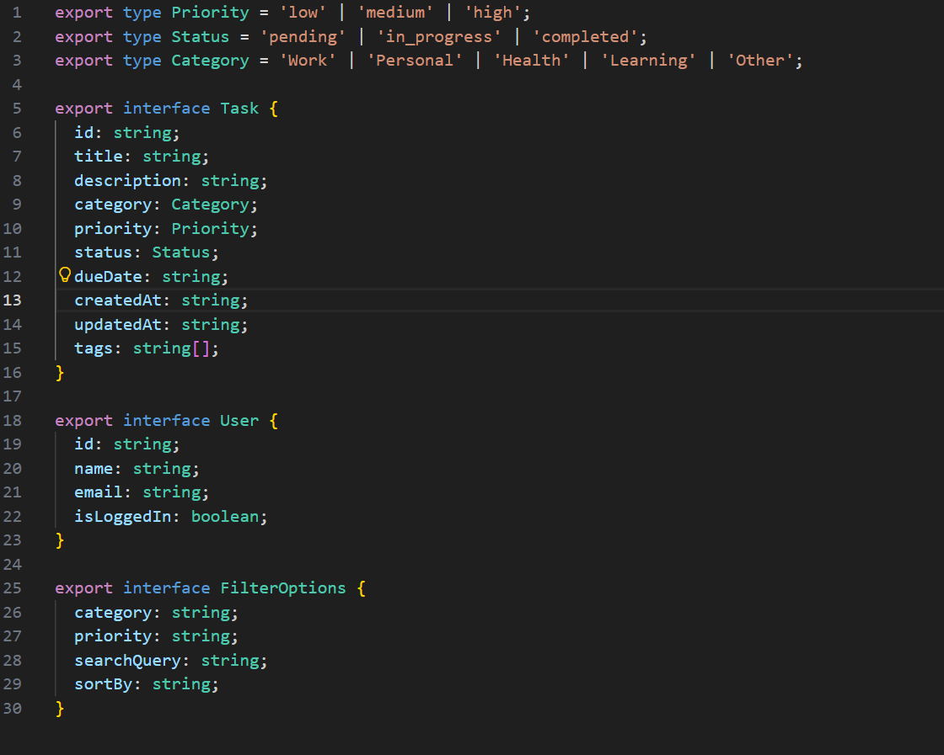
Filter Options Model

TaskService (task.service.ts)
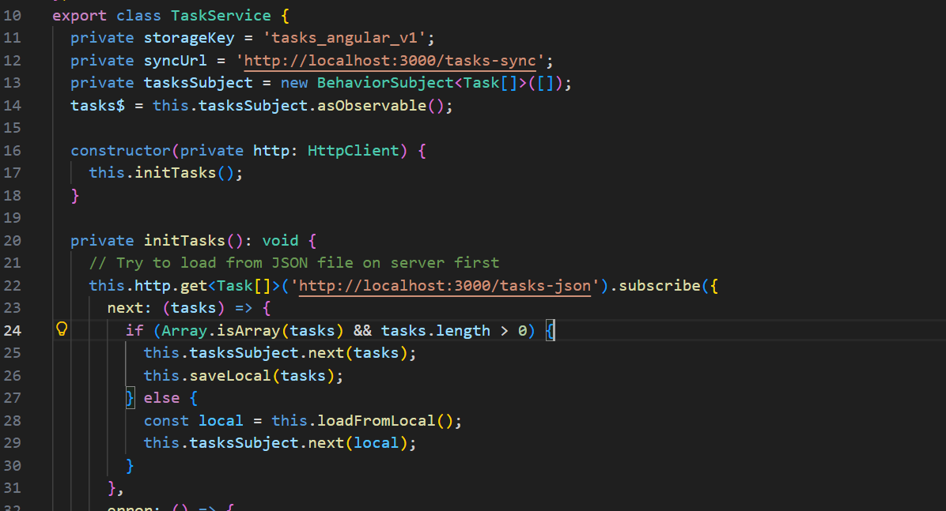
Routing and Navigation
Angular Router is configured with named routes for each view. AuthGuard protects the Add Task and Edit Task routes using CanActivate.
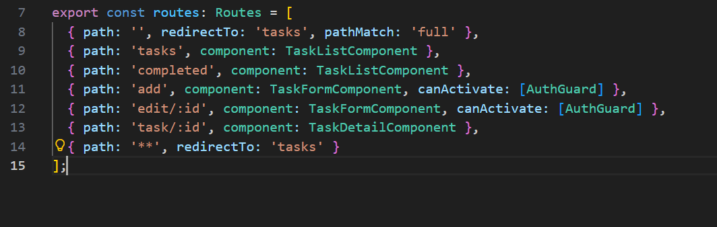

Data Stored:

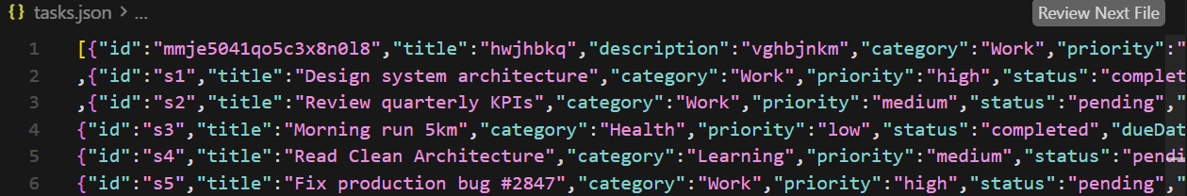

File Structure:
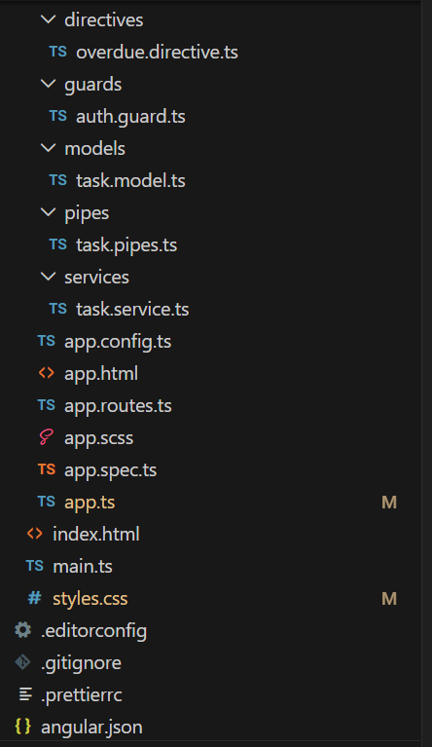
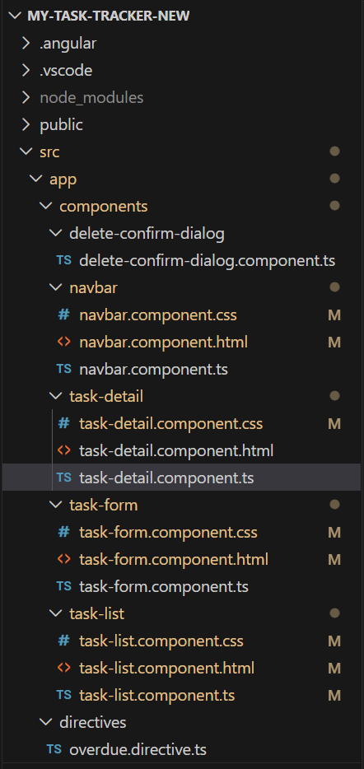

SAMPLE OUTPUT
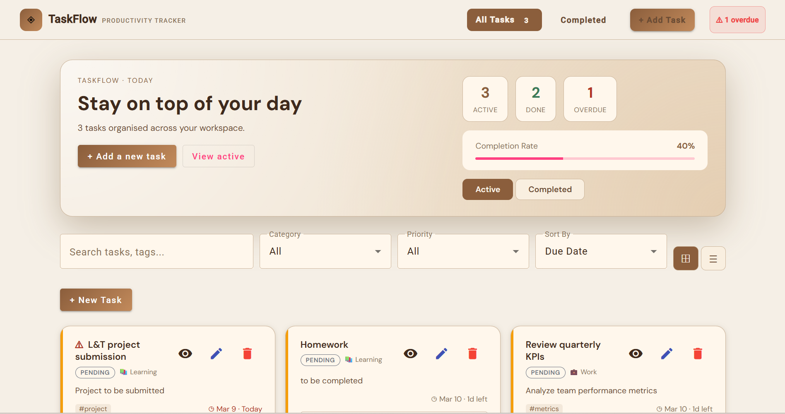

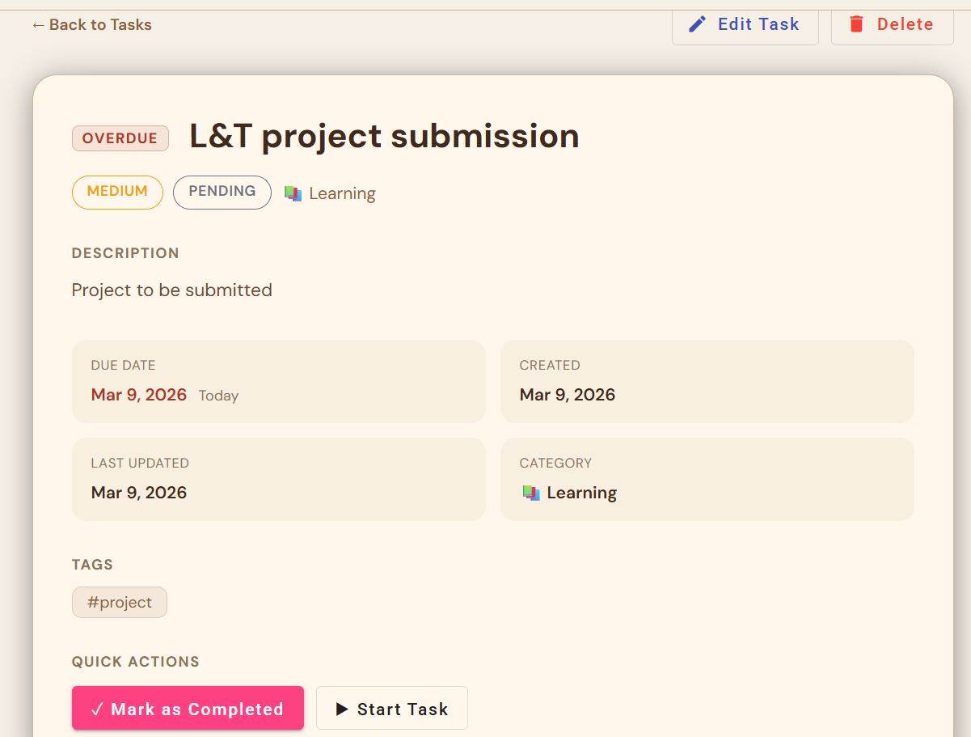
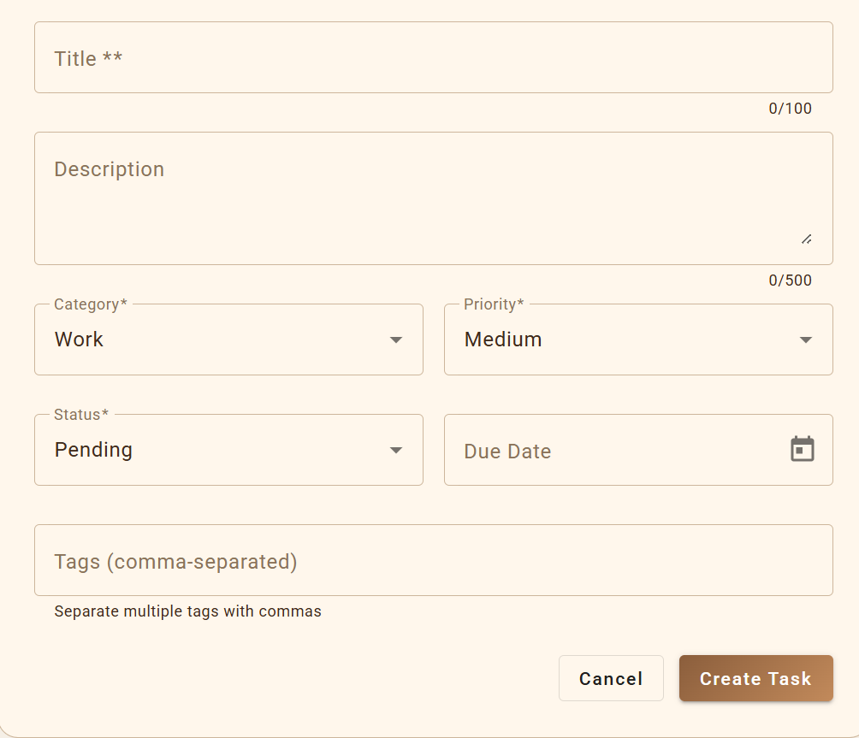
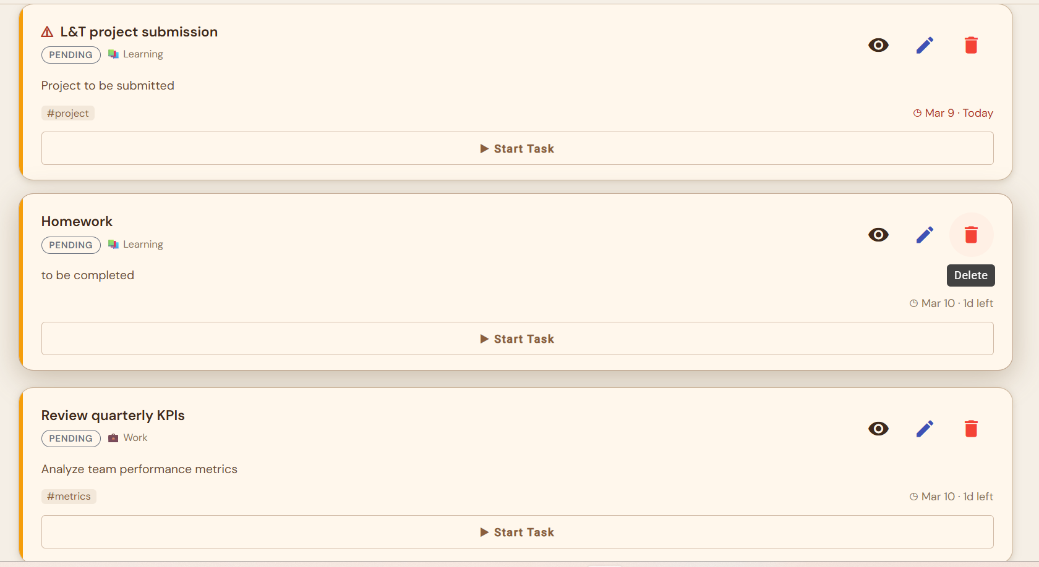
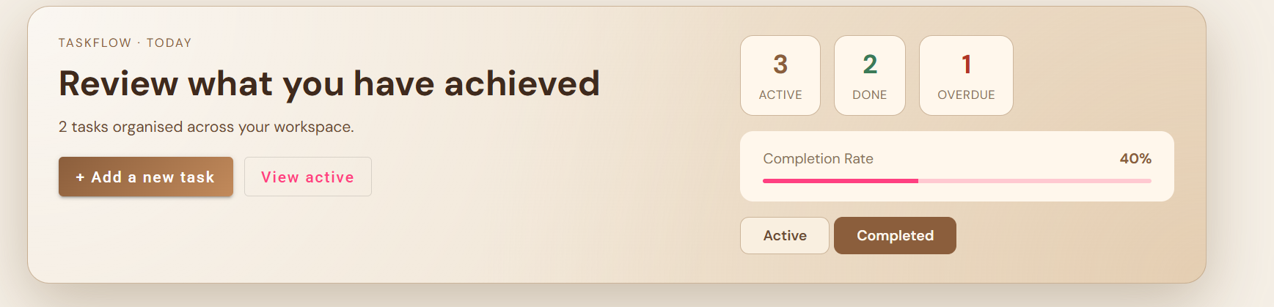

Conclusion
The Task Management and Productivity Tracker project demonstrates a comprehensive implementation of Angular framework features in a real-world application context. Through this project, the team gained hands-on experience with component architecture, reactive programming with RxJS, Angular Material UI, TypeScript type safety, and Angular's dependency injection system.

The application is fully functional, covers every requirement in the project specification, and serves as a strong foundation for future expansion into a production-ready task management system.

REFERENCES
- W3Schools – HTML, CSS, TypeScript
- Angular Documentation (Conceptual Reference)
- UI/UX Design Fundamentals Course Material

